LED Software Operation Manual
1.Installation Software

1>.Click ”powerled.exe” on the CD-ROM to setup the application!

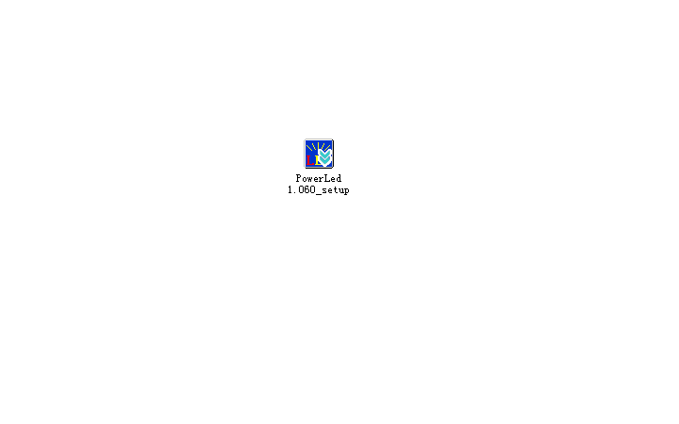

2> Choose the install language,click “English”, as below.
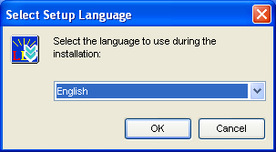
2.Software interface

1> Software Overview
Software during normal operation of the interface shown in Figure 3, mainly by the
“Tool area”,”"Program List","set area”, “Editor area “,"Preview area”, five parts.

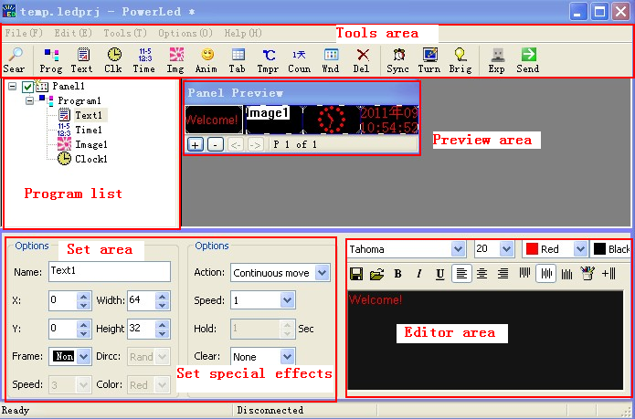

Figure 3 the software main interface.
- Tools area
- , Find information on the control card
2>,Add to the list of programs in the display
3>, Add analog clock
4>. Add a digital time
5>, support bmp, jpeg and other image formats.
6>,Used to add animated text
7> ,Adding a document for forms
8> ,Adding temperature and humidity display (temperature and humidity module must be added)
9> .,use to add count down.
10>, ,Add document window（you can add this: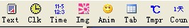)
11>, Delete the current program or the information window

12>, Make the computer and control cards time synchronization

13>,make the LED screen blackout
14>, Adjust the display brightness, the brightness can be time-change, or a grade of brightness throughout the day.

15>, Export the edited content to the U disk.

16>, Send edited content to the control card.
- Program List

Program list column used for program management,it is including this:
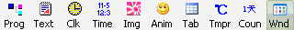.In the program list ,you can add any type of a program ,if you need. You can add up to 200 different programs.
As shown
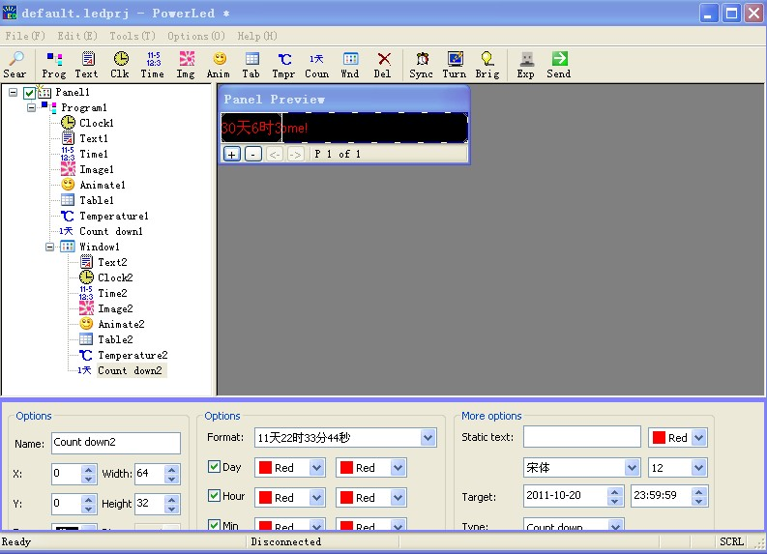
- Editor area
Different types of programs has different editors area, its location is generally in the lower right foot. A typical window, such as: TEXT type of program..As shown.
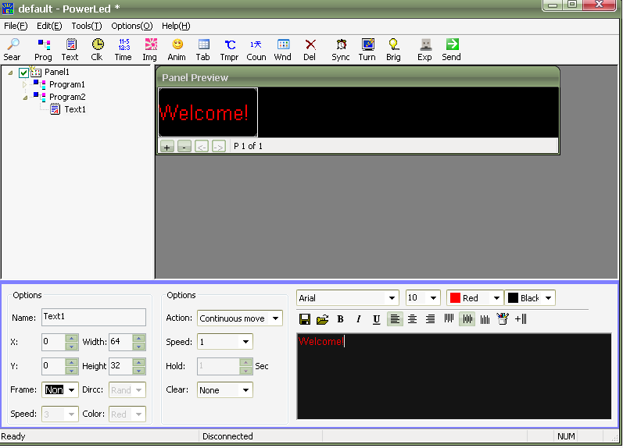
- set area
You can set the program according toyour own need in the settings area, you can set the program location, size. Broadcast time effects, playback speed and other characteristics.

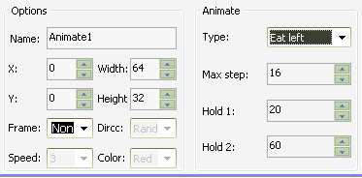

⑤Preview area
LED software preview window is an important part of control software, which simulates the actual display basically the same as display effect
Preview: program editing is completed in preview window shows the effect of a single observation.
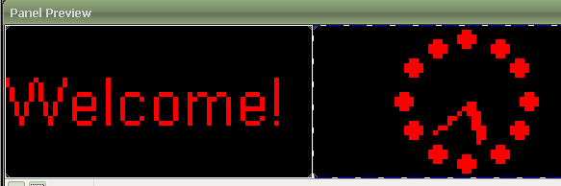

>: The 4 steps for use software
Send programs by button 

